# Project Development Phase Delivery of Sprint – 2

|  |  |
| --- | --- |
| Team ID | PNT2022TMID04961 |
| Project Name | Retail Store Stock Inventory Analytics |

Project Development Phase:

Sprint – 1: Sprint – 2:

Data Collection Data Preparation Data Preparation

Sprint – 3: Sprint – 4:

Dashboard Creation Report Creation Story Creation

Team ID: PNT2022TMID04961

Team Lead: Jayapal G

Team Member 1: Karthipranav G Team Member 2: Karthik Kumar M

Team Member 3: Kumaresh Babu R

# Sprint – 2:

**Data Exploration:**

* **Month data hierarchy coloured by year and sized by sales**
* **inventory by year**
* **inventory by Month data**
* **inventory for Month data**
* **price and sales by Month data**
* **sales to price with line width inventory**
* **inventory Summary**
* **price sized by year**
* **sales by price**
* **sales and inventory by Month data**
* **price Decision Tree**
* **inventory Sprial**
* **sales by inventory with points for price**

Tool Used: IBM Cognos Analytics

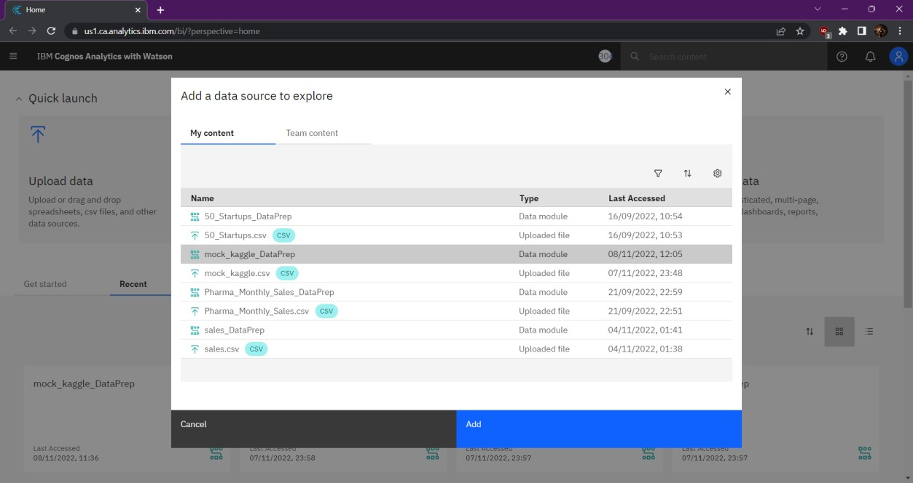

Month data hierarchy coloured by year and sized by sales

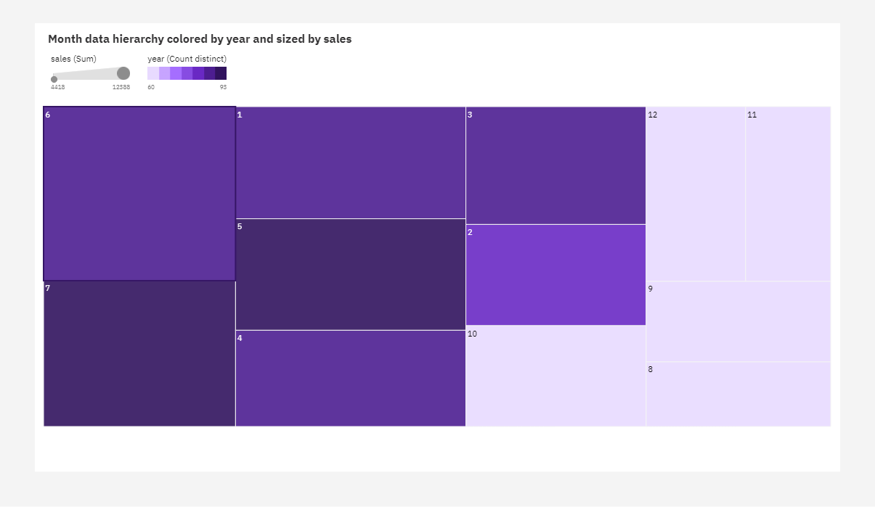

Inventory by year:

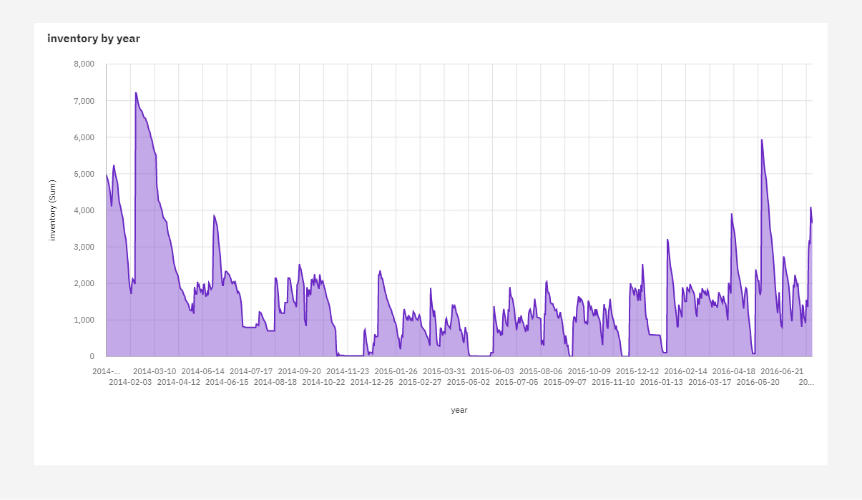

**Inventory by Month data:**

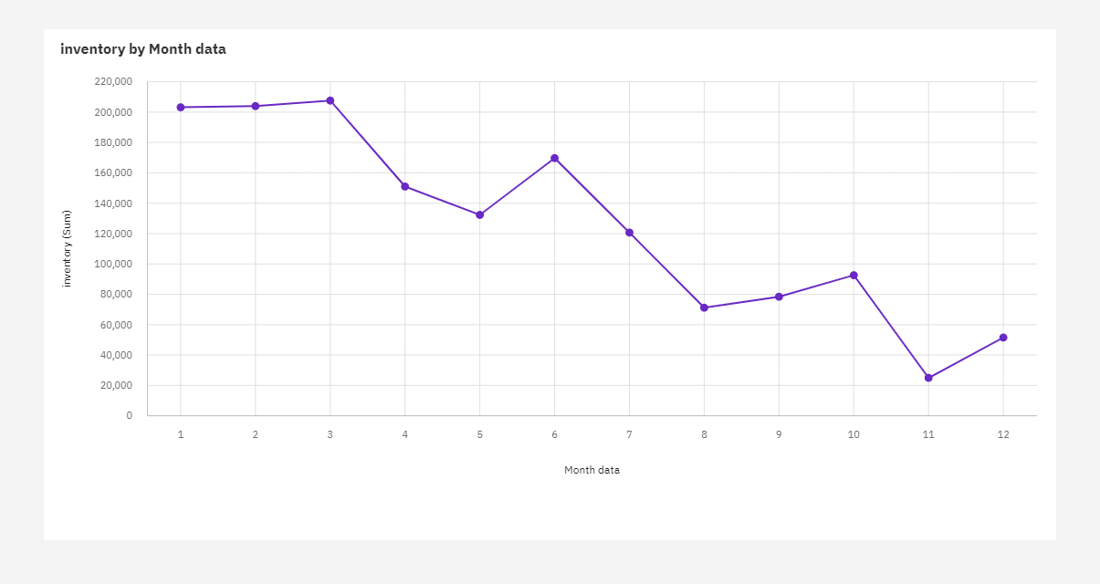

**Inventory for Month data:**

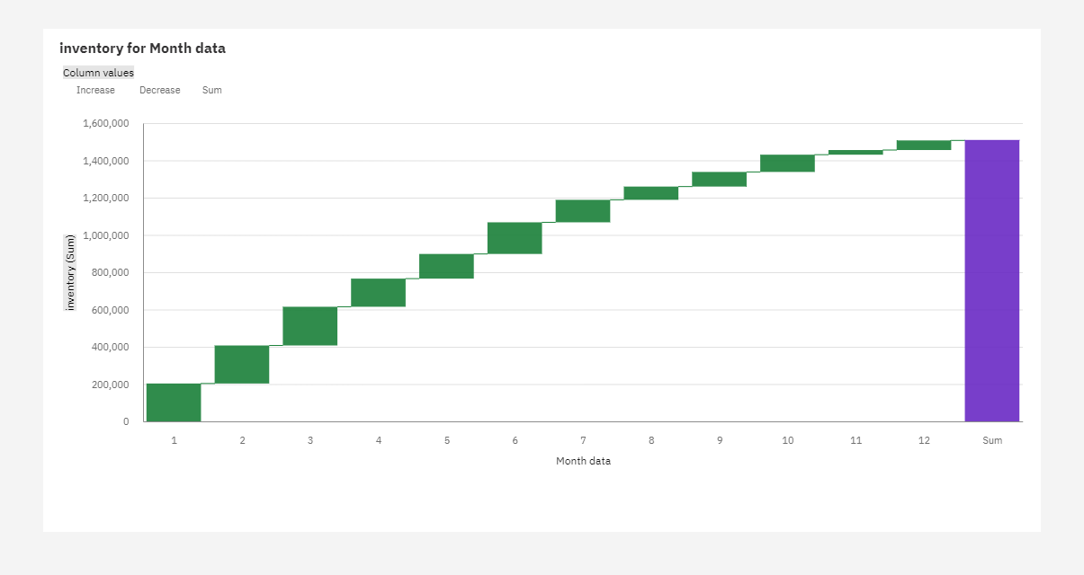

**price and sales by Month data:**

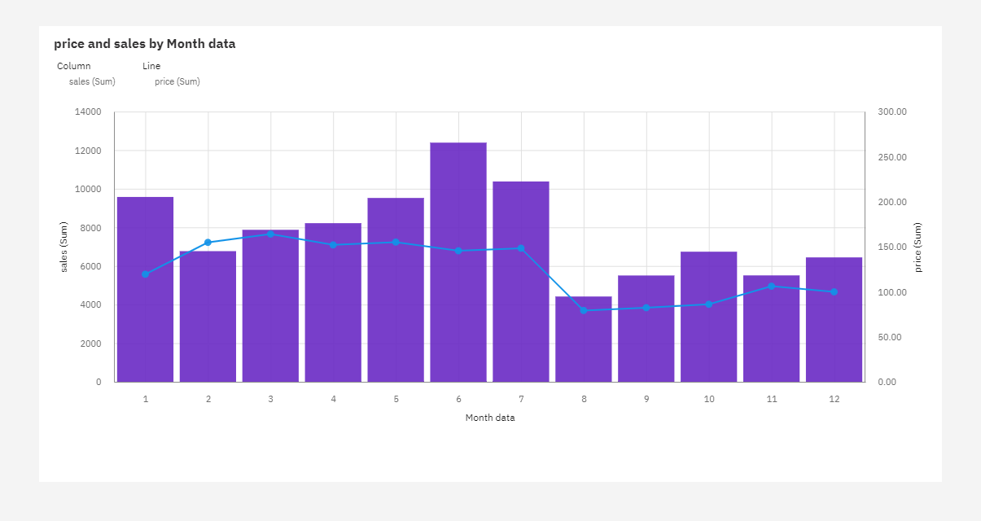

**sales to price with line width inventory:**

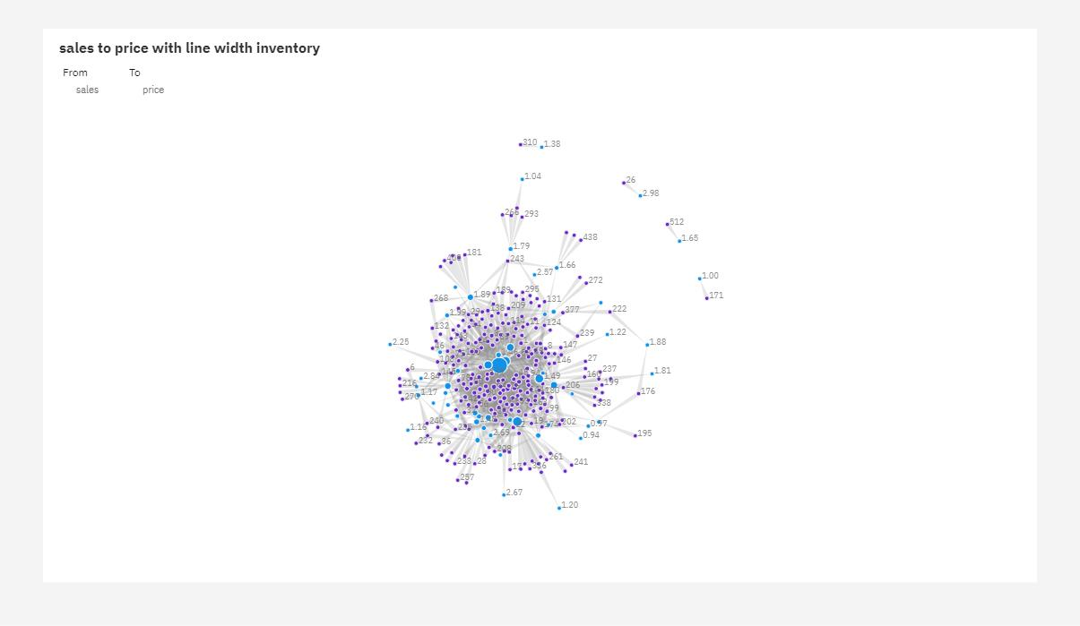

**Inventory Summary:**

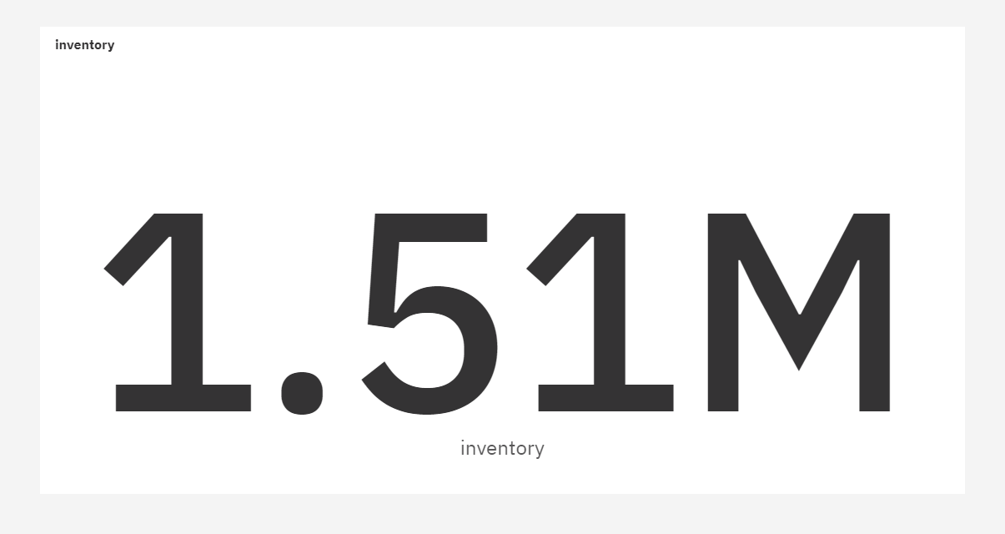

**price sized by year:**

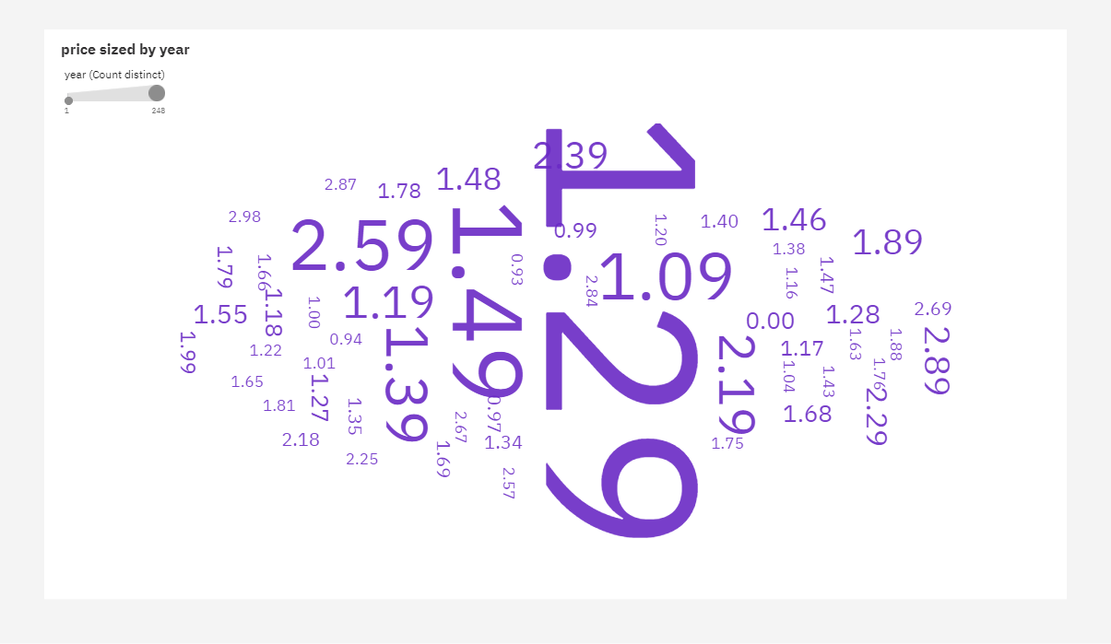

**sales by price:**

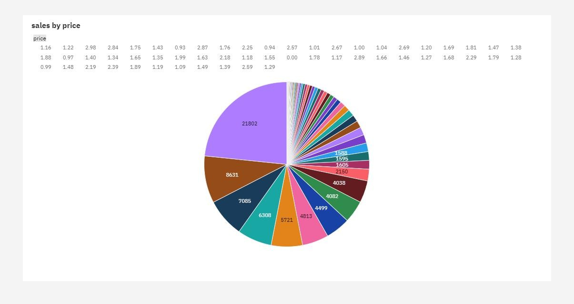

**sales and inventory by Month data:**

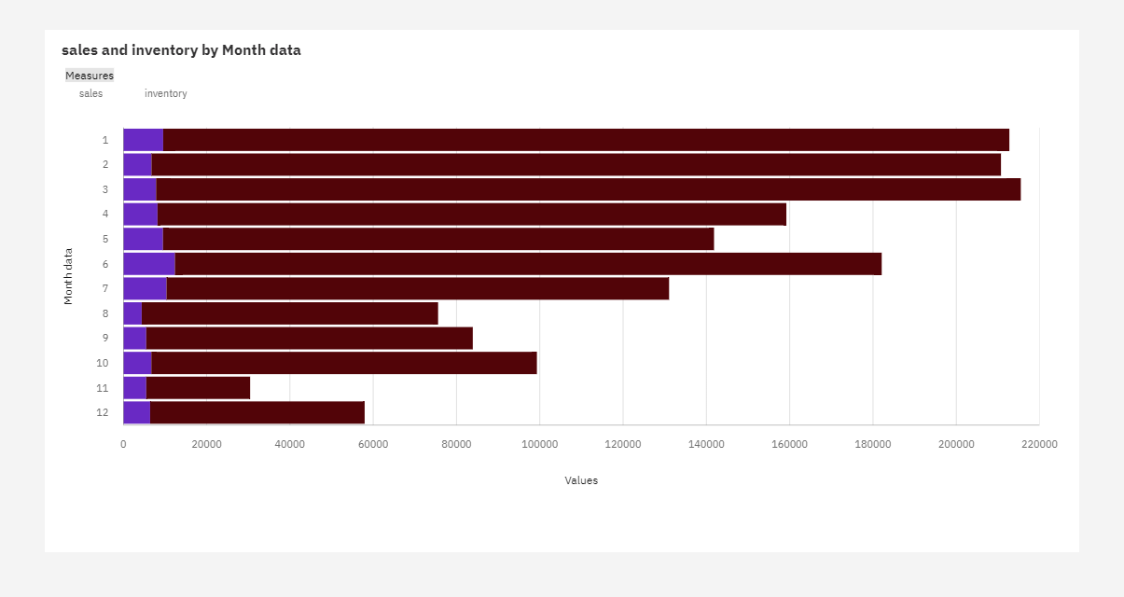

**price Decision Tree:**

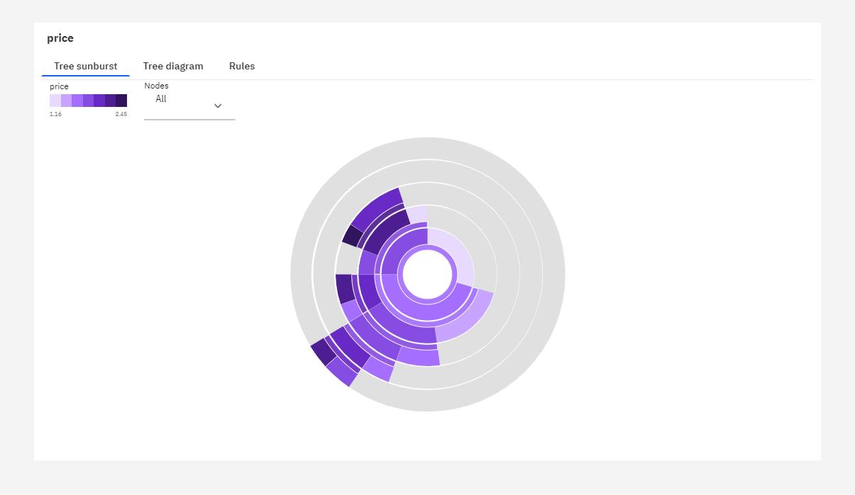

**inventory Sprial:**

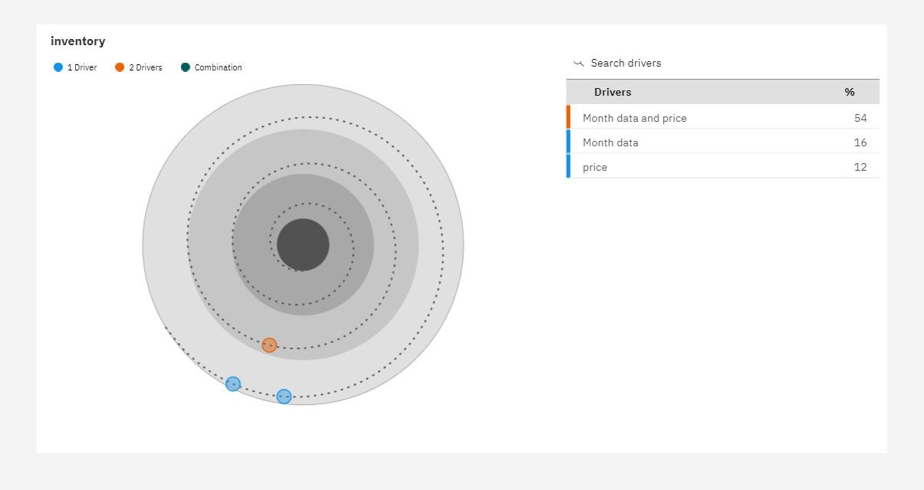

**sales by inventory with points for price:**

